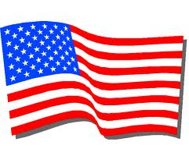
Frederick Keys Baseball Game Fundraiser
Bonnie Branch Musicians will perform
THE NATIONAL ANTHEM
at the Frederick Keys game on Sunday, May 17, 2015, 2:00 p.m.

Tickets required for every person attending the game, including performers. Tickets cost $8 each. Please detach the form below and return to school with payment by Thursday, April 30, 2015. Please put “Music Boosters” on the envelope.
Purchased tickets may be picked up at Bonnie Branch Middle School Spring Concerts on May 13 and May 14.
Special notes for performers:
Arrive at the meeting place inside the stadium no later than 1:00 pm (location To Be Announced)
Wear your Hershey Park T-shirt OR a black t-shirt.

---------------------------------------------------------------------- CUT HERE ---------------------------------------------------------------------------
If you are in band, chorus, or orchestra and want to perform or sing, check here:
First and Last Name of student(s):____________________________________________________________
Number of tickets: _____________
Please indicate your payment method (tickets cost $8 each):
PayPal -- go to http://bbmsmusicboosters.weebly.com/frederick-keys.html NOTE: 1) Please include a copy of your email receipt that includes the PayPal transaction ID 2) a small processing fee applies.

Check Enclosed. Amount: $________________ Check Number:_______________
NOTE: payment to “Bonnie Branch Music Boosters”

Please provide us with the following information so that we may contact you “last minute” if needed. If you provide a mobile phone number, we may send you a few text messages on the day of the game.
Email address:__________________________________________________________
Mobile phone number:___________________________________________________

